**Name: -** Shahrukh Padaniya

**Student Id: -** C0769542

**1014**

**LAB ACTIVITY: - April 1,2020**

1. Simulate the circuit using MultiSim
2. Prototype PCB using KiCad



1. Kicad design:-

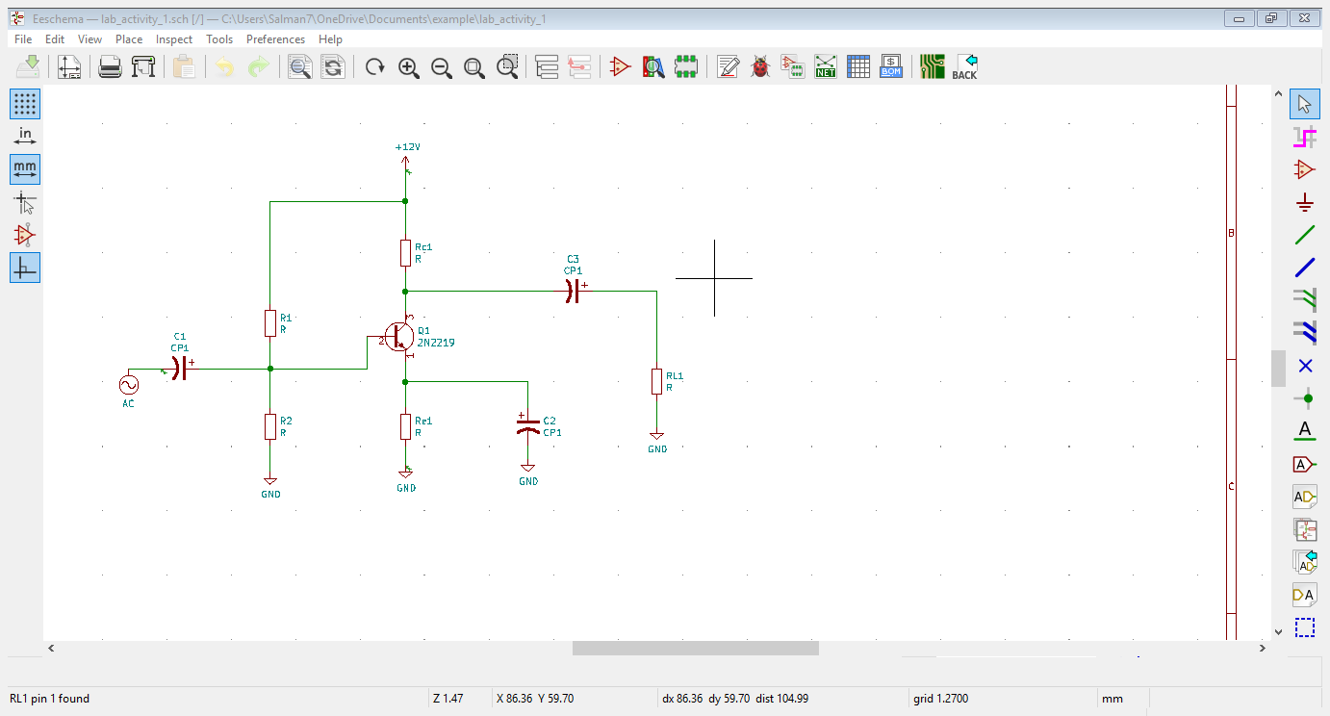

Schematic design

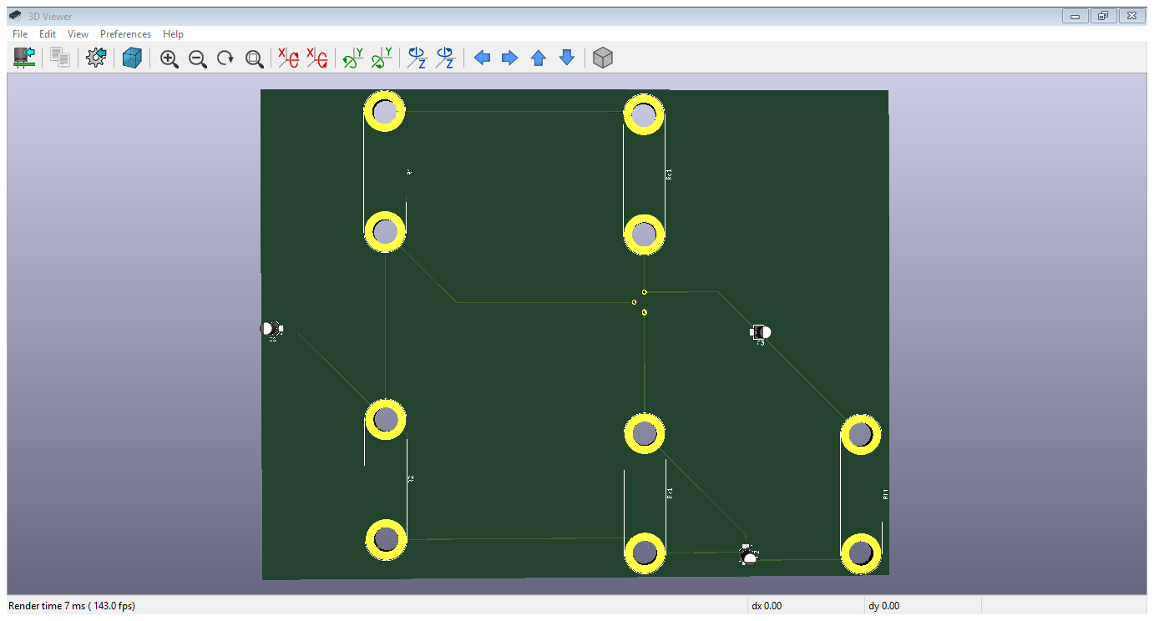

3D view

2)MultiSIM

DC op

